18.32: (Many calculators have statistics functions that are preprogrammed for such calculations as part of a statistics application. The results presented here were done on such a calculator.) a) With the multiplicity of each score denoted by 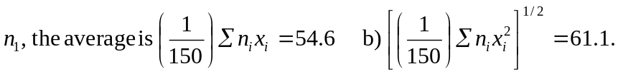 (Extra significant figures are warranted because the sums are known to higher precision.)

